**Development of tolerance model images**

Images were created from 400 random seeds located along a Cartesian plane modelled as a cylinder, with resolution 1024x512 pixels. A total of 20 images were generated randomly from a same number of seeds. For each image, 20 realizations were carried out following the Lloyd’s algorithm [XXXX], this process keeps similarities with the CVT path [XXXX] with the unique particularity of modelling a cylindrical structure. To maintain the cylindrical pathwork along algorithm’s iterations, we have employed a strategy based on triplicating the plane in the X axis at time of placing seeds. Therefore, we have worked with images of 1024x1536 pixels with 1200 seeds, locating 400 seeds identically distributed for each of the three subsequences of 1024x512 pixels. Afterwards of Voronoi assembling, we constrained by [513-1024] pixels in X axis, getting again an 1024x512 image. The result was a continuous mosaic Voronoi simulating a cylindrical configuration.

**triangulation and tolerance calculation**

Using mentioned modeled images, we have carried out diverse geometrical reckonings to get an explanation related with presence of ‘Scutoids’ in tissues. The mathematical tool that we have mainly used is the tolerance concept [XXXXAbellanas et al]. Tolerance say us how easy is breaking the wall of ‘Scutoid’ cell shaping, beginning from a cellular face. When tolerance was smaller than ‘pi’ **[Define pi]**, a ‘Scutoid’ cell could be present. First, it is necessary achieving a Delaunay triangulation [XXXX???] in our image to test. This triangulation, was developed joining linearly centroids of neighboring cells by means of edges. The edges located between two no valid cells can’t be consider for our analysis, but all the rest were our objects to study. So, we contemplate a total of two triangular configurations in which an edge is involved. Figure 1 is composed by these triangulations between neighboring cells, where edge is illustrated as a blue line connecting C1 and C2 centroids. A circumference is built from C1, C2 and the middle point between them, another one is developed from C3 and C4 and the middle point between them again. So, to choose the pairs of centroids, we considered 2 neighbors joined by an edge, and the second one was chosen considering C1 and C2 common neighbors, C3 and C4. A third circumference was created taking into account a specified center and radius:

* Center, defined by the middle point between circumcenters of circumference 1 and circumference 2.
* Radius, calculated from the smallest circumference radius joining him the difference between largest and the first circumference radius.

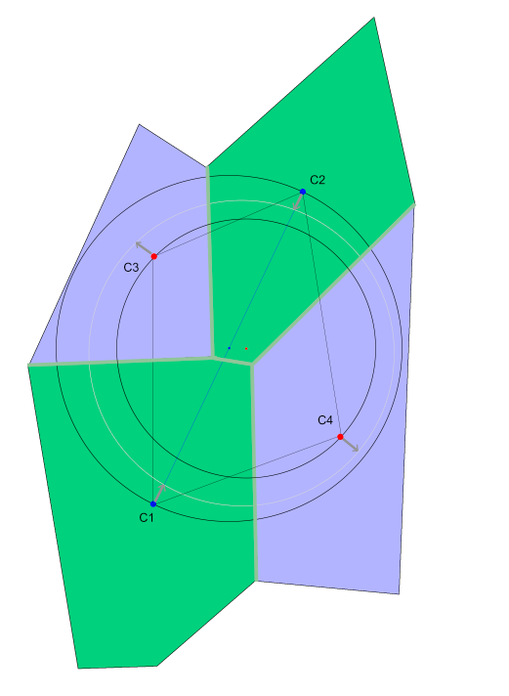Accordingly, shortest distance from centroids to new circumference will always be equidistant. This distance is the responsible of edge’s tolerance value. The minimum tolerance for a triangle would be the minimum triangle edges’ tolerance.